Color Palette:

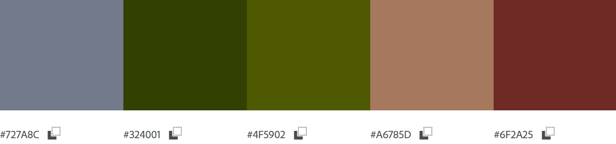

This color palette is simple and soothing without being boring. I can use light and dark fonts over the blue and pink colors, and the dark green and red will show light fonts on top wonderfully. The bright green and red can be used as attention-getting colors without being too obtrusive and obnoxious. These colors are pulled from my bio picture, so I also know they will not clash with my home or about pages.

Font:

Open Sans

Open Sans is simple and easy to read. It has many styles and glyphs within the font family for any needs.